CoffeeSaint


CoffeeSaint is a very much configurable Nagios status viewer. It is meant to be run on a screen on a wall, visible to all system operators. It is written in Java so you can run it on Linux, MacOS X, microsoft windows and all operating systems capable of running Java version 6 (or later) software. The name CoffeeSaint stems from the Oracle Java-logo being a cup of coffee and because the original name from Nagios is “Netsaint”.


Written by Folkert van Heusden.

http://www.vanheusden.com/java/CoffeeSaint/

Released with GPLv2 license.
Table of contents
Written by Folkert van Heusden. 1
www.vanheusden.com 1
Released with GPLv2 license. 1
Nagios configuration 5
Serve the file via inetd / xinetd 5
inetd 5
xinetd 6
Slow network links 6
Serve the file via a webserver 6
Serving as a compressed stream using Apache 6
Status via Livestatus 6
Starting CoffeeSaint without any tweaking (quick how-to) 8
Retrieving the status from inetd/xinetd 8
Without compression 8
With compression 8
Retrieving the status from a webserver 8
Retrieving the status from a Liveupdate connection 8
Retrieving the status from a local file 8
Easy configuration via web-interface 8
Web-interface parameters 8
Example 9
What you see 11
Commandline switches to list parameters 13
--list-screens 13
--list-fonts 13
--list-bgcolors 13
Configuring CoffeeSaint 14
source 14
allow-all-ssl 14
disable-http-compression 14
proxy-host and proxy-port 14
nrows 15
interval 15
flash 15
webcam-timeout 15
use-host-alias 15
fullscreen 15
image 15
adapt-img 15
ignore-aspect-ratio 16
random-img 16
transparency 16
header-transaparency 16
cam-cols / cam-rows 16
problem-columns 16
flexible-n-columns 17
logo 17
logo-position 17
anti-alias 17
max-quality-graphics 17
header 17
footer 18
no-header 18
sort-order 18
prefer 18
also-acknowledged 18
always-notify 18
also-scheduled-downtime 18
also-soft-state 18
also-disabled-active-checks 18
show-flapping 18
show-flapping-icon 19
filter-unknown 19
filter-down 19
show-services-for-host-with-problems 19
counter 19
counter-position 19
problem-row-gradient 19
bgcolor 20
bgcolor-fade-to 20
sound 20
exec 20
verbose 20
text-color 20
warning-textcolor 20
critical-textcolor 20
color-bg-state 21
warning-bg-color 21
critical-bg-color 21
nagios-unknown-bg-color 21
font 21
critical-font 21
warning-font 21
splitter 21
draw-problems-service-split-line 21
no-problems-text 22
state-problems-text 22
row-border 22
row-border-color 22
host-issue 22
service-issue 22
reduce-textwidth 22
scroll-if-not-fitting 23
scroll-pixels-per-sec 23
scrolling-header 23
hosts-filter-exclude 23
hosts-filter-include 23
services-filter-exclude 23
services-filter-include 23
sparkline-width 23
sparkline-mode 23
graph-color 23
performance-data-filename 24
Escapes 25
Font style escapes 25
Textual escapes 25
%CRITICAL 25
%WARNING 25
%OK 25
%UP 25
%DOWN 25
%UNREACHABLE 25
%PENDING 25
%TOTALISSUES 25
%STATE 26
%H:%M 26
%HOSTNAME / %SERVICENAME 26
%SERVERNAME 26
%HOSTSTATE / %SERVICESTATE 26
%HOSTSINCE / %SERVICESINCE 26
%HOSTSINCETS / %SERVICESINCETS 26
%HOSTFLAPPING / %SERVICEFLAPPING 26
%PREDICT / %HISTORICAL 26
%HOSTDURATION / %SERVICEDURATION 26
%OUTPUT 26
@FIELDDATEHOST^field@ 27
@FIELDDATESERVICE^field@ 27
@FIELDBOOLEANHOST^field@ 27
@FIELDBOOLEANSERVICE^field@ 27
@FIELDHOST^field@ 27
@FIELDSERVICE^field@ 27
@FIELD^x@ 27
@EXEC^script@ 27
%PERCENT 27
%AT 27
%CHECKLATENCY 28
%NACKED 28
%NFLAPPING 28

Nagios configuration
Nagios keeps track of its status in a file (mostly) called status.dat. This file is located somewhere in the filesystem. CoffeeSaint uses the contents of this file to display what is happing. There's also an other way which is discussed later on.
In case you choose to serve the status.dat file directly to CoffeeSaint then you need to find where it is. Open the file nagios.cfg and look for a line starting with status_file=
- Default Nagios installation: /usr/local/nagios/var/status.dat
- Debian: /var/cache/nagios3/status.dat
- Groundwork: /usr/local/groundwork/nagios/var/status.log
- EPEL (Fedora or RedHat enterprise Linux): /var/log/nagios/status.dat
CoffeeSaint can access the status.dat file in a couple of ways.

Serve the file via inetd / xinetd
Most UNIX systems have either inetd or xinetd running. This program listens on a couple of TCP and UDP ports and, if a connection is made, (x)inetd starts a program which handles the connection. The difference between inetd and xinetd is mostly the configurationfile. For both options you need to select a TCP port to listen on. This can be, for example port 33333. Verify using netstat -na if this port is free or not:
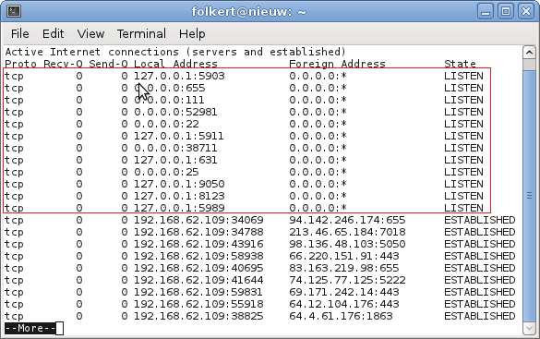
In this example the entries with “LISTEN” at the right are in use. E.g. port 655, 111, 52981, etc.

inetd
For inetd, you then need to edit /etc/inetd.conf and add the following line:
33333 stream tcp nowait root /usr/sbin/tcpd /bin/cat /var/cache/nagios3/status.dat
Please note that you need to change the '33333' in this example to a free port number on that server. Also you need to replace /var/cache/nagios3/status.dat to the location of the status.dat on your system. This example-location is for Debian.
Don't forget to restart inetd.

xinetd
For xinetd you must create a file called /etc/xinetd.d/nagios.
service nagios
{
disable = no
socket_type = stream
protocol = tcp
wait = no
user = nagios
server = /bin/cat
server_args = /var/cache/nagios3/status.dat
}
After that add the following line to /etc/services:
nagios 33333/tcp
Just like the inetd example you need to adjust the portnumber (33333) and status.dat location.
Do not forget to restart xinetd.

Slow network links
It can happen that the connetion between the Nagios server and the CoffeeSaint program is slow, for example when there's an internet-connection between them. In that case it can help to first compress the status.dat first before serving it to clients. To do this, replace /bin/cat with /bin/gzip or /bin/gzip -c9 for maximum compression.

Serve the file via a webserver
This is just a matter of either:
- moving the status.dat to somewhere underneath the document root of your webserver. This might give problems with access rights.
- creating a symbolic link from the status.dat file to somewhere underneath the document root of the webserver. You might need to tweak the webserver configuration so that it allows symbolic links in its document tree.

Serving as a compressed stream using Apache
Change your Apache configuration file to include the following lines. On Debian systems this can be found at /etc/apache2/mods-enabled/deflate.conf.
<IfModule mod_deflate.c>
AddOutputFilterByType DEFLATE text/html text/plain ... application/x-ns-proxy-autoconfig
</IfModule>
The part which matters is “application/x-ns-proxy-autoconfig”.

Status via Livestatus
Nagios can deliver its status to client tooling via the Livestatus interface. This is a nagios add-on, e.g. it requires changes in the nagios.cfg file as well as adding a module. For details how to configure Nagios, see the following web-site: http://mathias-kettner.de/checkmk_livestatus.html
For example this can be:
broker_module=/usr/local/mk-livestatus/lib/mk-livestatus/livestatus.o /var/lib/nagios3/rw/live event_broker_options=-1
This sets up a UNIX domain socket.
Livestatus sets up a UNIX domain socket. This socket can then be served via a TCP socket. Serving this TCP socket via inetd:
6557 stream tcp nowait root /usr/sbin/tcpd /usr/local/mk-livestatus/bin/unixcat /var/lib/nagios3/rw/live

Don't forget to restart inetd.

Starting CoffeeSaint without any tweaking (quick how-to)
You need to adjust the parts written in bold. E.g. “mynagiosserver.local” should be replaced with the host-name or IP-address of the Nagiosserver, 33333 by a portnumber.
All examples below are for a Nagios version 2, 3 or Xi server. Replace e.g. 'tcp 3' by 'tcp 1' for old Nagios v1 compatibility.

Retrieving the status from inetd/xinetd
Please note: behind the –source you add a 'pretty_name': this parameter is then set to %SERVERNAME escape.

Without compression
java -jar CoffeeSaint.jar --source tcp 3 mynagiosserver.local 33333 pretty_name
Change the server as wel ass the port number ('mynagiosserver.local' and 33333).

With compression
java -jar CoffeeSaint.jar --source ztcp 3 mynagiosserver.local 33333 pretty_name

Retrieving the status from a webserver
java -jar CoffeeSaint.jar --source http 3 http://myserver.local/status.dat pretty_name

Retrieving the status from a Liveupdate connection
java -jar CoffeeSaint.jar --source ls 3 mynagioshost.company.com 6557 pretty_name

Retrieving the status from a local file
java -jar CoffeeSaint.jar --source file 3 /var/cache/nagios3/status.dat pretty_name

Easy configuration via web-interface
CoffeeSaint includes a build-in easy to use webserver. This webserver has a couple of functions, one which is configuring CoffeeSaint. If you start fresh without an existing configuration file, then first create an empty file which will be replaced with the settings you chose. On UNIX systems this can be accomplished with: touch myconfigfile.conf
Starting CoffeeSaint with the web-interface
java -jar CoffeeSaint.jar --listen-port 12340
You need to replace 12340 with a port number not in use.

Web-interface parameters
These settings can also be put in the configuration file. “--listen-port” would then become “listen-port”.
- --listen-port: the TCP port on which the web-interface will listen. So if the CoffeeSaint pc has network name 'cs.local' and you select port 12340, you would then point your web-browser to http://cs.local:12340/
- --listen-adapter: if the CoffeeSaint pc has multiple network-adapters then with this parameter you can select the network adapter to listen on. Default is to listen on all interfaces.
- --web-username: (use with --web-password) selects the username required for the webinterface.
- --no-authentication: disable authentication in the web-interface
- --disable-http-fileselect: Do not allow web-interface to select a file to write configuration to. Useful if CoffeeSaint is running on a public system.

Example
Configuring CoffeeSaint
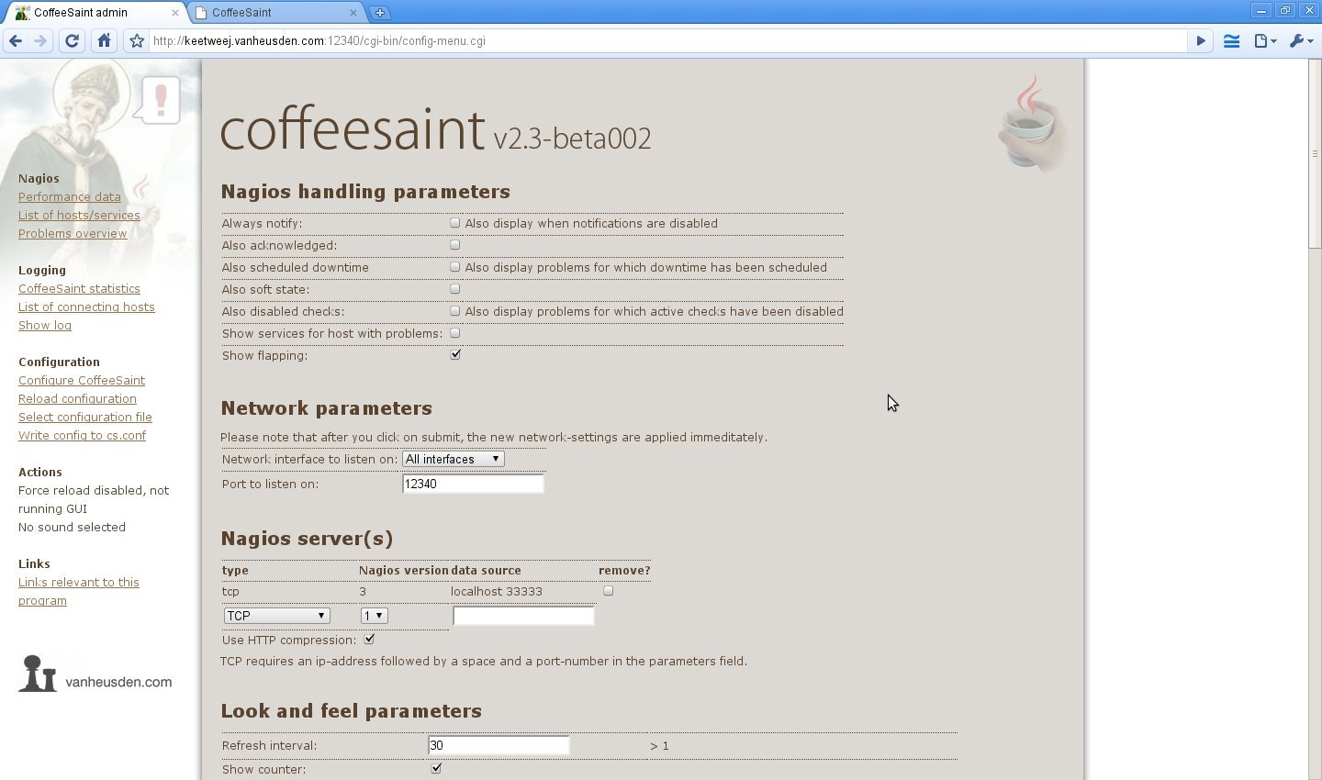
Performance graphs
Click on a host/service to zoom in into a graph.
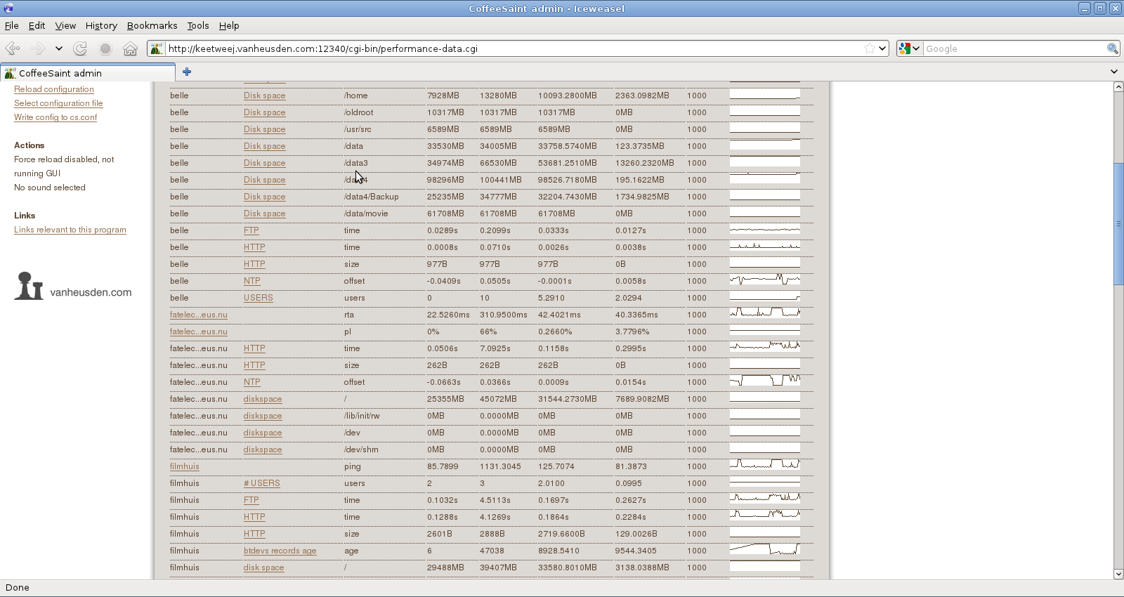
Applet mode
If you select “problems overview” in the menu, you can run CoffeeSaint as a web-browser applet. That way you can install it in 1 location and view if everywhere:

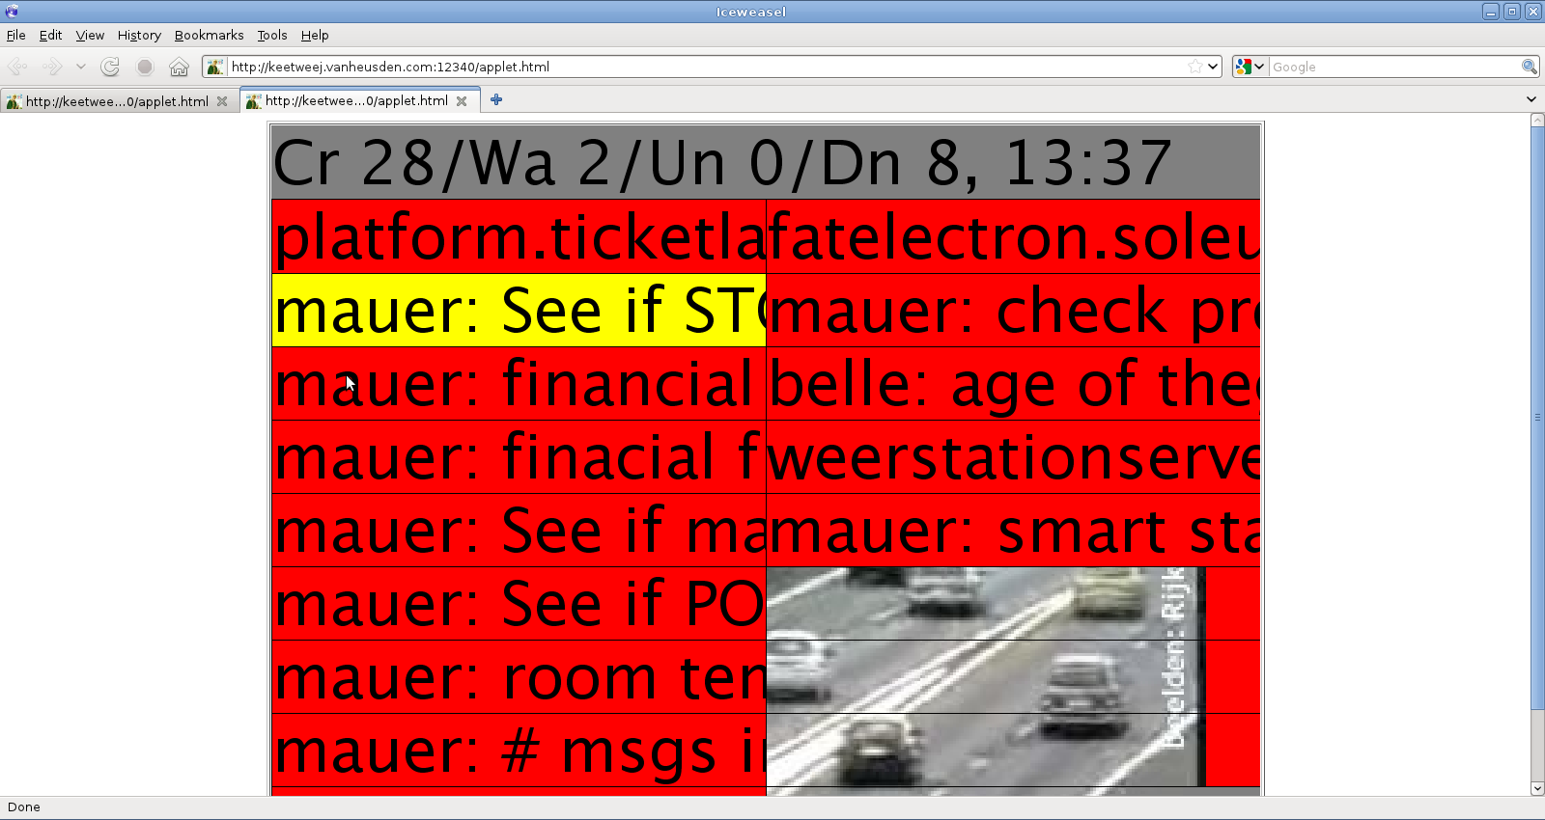

What you see
When the program is loading the Nagios status (via the network or a file) a blue block is drawn in the upper right top-row. If the loading failes in any way, this blue block is replaced by a red block and in the lower row an explanation is shown.


Also in the upper row a couple of values are displayed. These tell you the number of critical, warning and ok statusses as well as the number of up, down, unreachable and pending hosts. The contents of this row can be configured with the --header commandline switch as well als the “header = ...” configuration file setting.
Of course, you can disable the header-line. Use “--no-header” (or “header = false” in the configuration file) for that.
One can also click on a problem to get a pop-up with some more details:
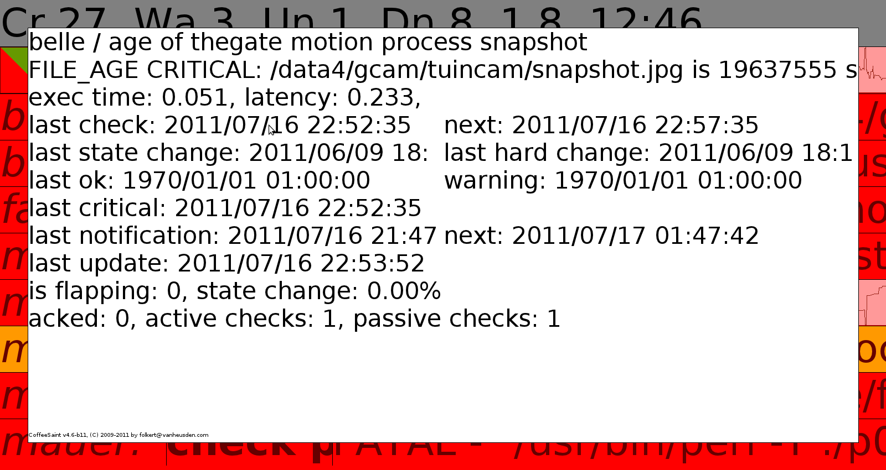

If you click on the header-line instead, you'll get more general information:

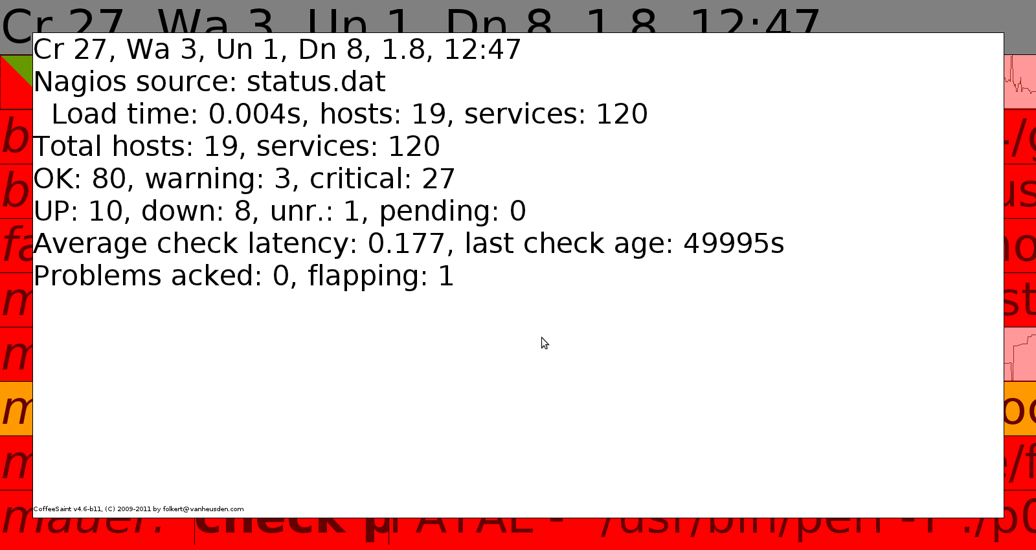

An example of a common configuration:

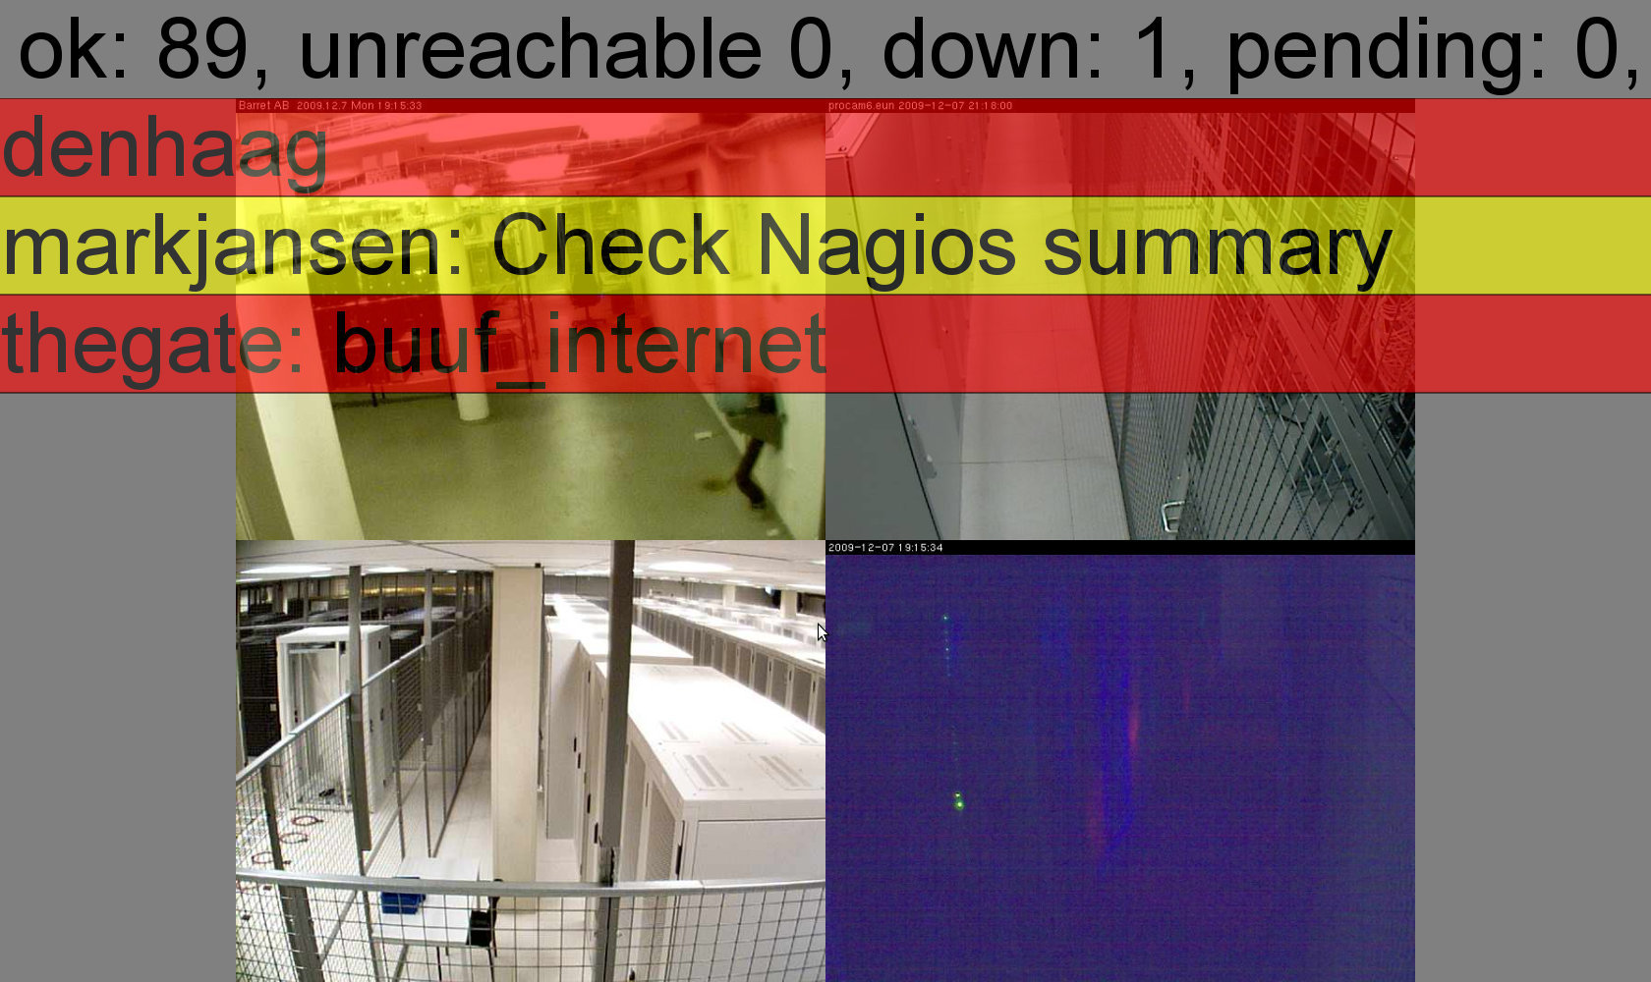

Commandline switches to list parameters

--list-screens
Shows a list of screens in the system. For example multiple monitors connected to one system. You can then either use all screens (--fullscreen allmonitors) or select one (--use-screen x where x is one of the identifiers returned with –list-screens).
On UNIX/Linux this will look like this:

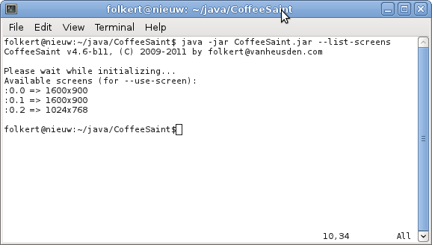

On microsoft windows xp this will look like this:

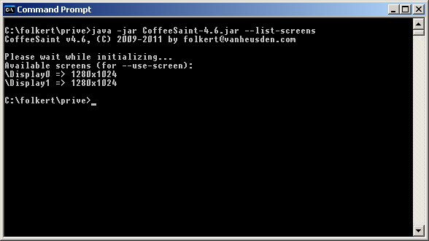

--list-fonts
Shows a list of fonts known by the system. Can then be used with e.g. “--font fontname”. Note: in Windows, Java ignores your vector, bitmap and PostScript fonts. It can only use the TrueType and OpenType fonts. Further it will only use TrueType and OpenType fonts with Unicode encodings. Older fonts or fonts with only a few specialty characters will often not work because they come only with 8-bit encodings. Modern fonts often come with several encodings. Java just uses the Unicode encoding. See http://mindprod.com/jgloss/font.html for more details.

--list-bgcolors
Shows a list of color names known by CoffeeSaint. Used with for example “--warning-textcolor x” and “--textcolor x”.

Configuring CoffeeSaint
CoffeeSaint can be configured with parameters on the commandline and/or via a configuration file.
To see a list of command line switches, run CoffeeSaint with the --help switch.
In short: a commandline switch can be placed “as is” in the configurationfile: --interval 30 would become interval = 30 in the configuration file. Start CoffeeSaint with --config myconfigfile.conf to use that file.
You select the configuration file with “--config filename”. Please note that “--config” must be the first parameter on the command-line as it overwrites all previous settings.
A couple of settings refer to nagios status.dat-file fields: those are listed in the chapter “Nagios status.dat fields”.

source
Defines a Nagios status-source. You need to have at least one and can have many more of them.
- source = type version file/url/host+port pretty_name
- type can be:
- http: expects an URL to retrieve the status from a webserver
- http-auth: retrieves the status from a http server with basic authentication. After the url you need to enter the username and password
- tcp: retrieve the status.dat from a socket, e.g. via inetd/xinetd. Requires a hostname/IP-address and a port number.
- ztcp: retrieve the status.dat compressed with gzip compression from a socket. Requires a hostname/IP-address and a port number.
- ls: retrieve the status from a Livestatus source. Requires a hostname/IP-address and a port number.
- file: retrieve the status from a local file (can be on an NFS or other network filesystem as well)
- version can be 1, 2 or 3. For Nagios Xi use 3. 2 and 3 are basically the same.
- file/url/host+port/etc. depends on the source-type.
- pretty_name since version 4.6 of CoffeeSaint you can give each Nagios-source a pretty name. This then will be shown if there are problems (in the footer-line at the bottom) or when using the %SERVERNAME escape).

allow-all-ssl
When using a http-source with an https-URL this makes CoffeeSaint ignore certificate issues. Usefull for example if the webserver uses a self-signed certificate. If this is used on the command-line, it must be the first parameter (AFTER “--config”), before the --source switch. In the configuration file it expects either 'true' or 'false'.

disable-http-compression
If you're retrieving the Nagios status via a webserver, in some cases the webser may automatically compress the data before transmitting it to the client. This may not be required on a LAN. With this parameter you can forcibly switch compression of. Must be 'true' or 'false'.

proxy-host and proxy-port
When retrieving the nagios status via a webserver you might need to configure a proxy-server. With proxy-host and proxy-port you can set this up.

nrows
This tell CoffeeSaint how many rows you want. Default is 10. This includes the header-line and the optional footer-line.

interval
How often to refresh the screen. This selects the interval in which the status is retrieved. In seconds. Default is 30.

flash
In some occasion you may have a couple of problems listed on the screen which have been there for a while. Then if a new problem shows up and no warning sound is selected you might miss that event. With 'flash = true' you let CoffeeSaint flash this new entry for the duration of one refresh-interval.

webcam-timeout
Using the 'image' parameter you can show an image or webcam on the background. If you're displaying a remote image and the remote server is down, this might take a while. With this parameter you can select how long to try – in seconds.

use-host-alias
Show the “pretty name” of a nagios-server instead of the hostname.

fullscreen
Display CoffeeSaint in full-screen mode. This mode has a couple of modusses:
- undecorated: a window without borders
- fullscreen: no menu bars
- allmonitors: spread out over all monitors
- none: windowed mode

image
Selects one or more images to display on the background. Can be remote images, e.g. webcams in the serverroom. Requires 2 parameters: type and a path/url.
- file: selects a file in the local/mounted filesystem(s)
- http/https: select is an image on a remote webserver.
- mjpeg: selects a MJPEG stream on a remote webserver. Displays one new frame every 'interval' seconds.

adapt-img
Shrinks (or enlarges) the image (selected with 'image') to fit underneath the list of problems.

ignore-aspect-ratio
Grow/shrink all webcams with the same factor. In case you have images with different dimensions.

random-img
When selecting multiple images, CoffeeSaint randomly selects one to display each interval. Default behaviour is to display them in order of appearance on the commandline or configuration file.

transparency
Gives a “see-through” effect. 0.5 means 50% see through. So you'll see the background image shimmer through the problem-text.

header-transaparency
Like 'transparency' but only for the header-row.

cam-cols / cam-rows
Number of images to display on a row (cam-cols) and the number of image-rows to show (cam-rows).

problem-columns
For really wide screens it might be usefull to split the screen in multiple columns. With this parameter you set the number of columns. Must be a value of 1 or bigger.

flexible-n-columns
Automatically increases the number of columns in case the number of problems is bigger than the 'nrows' parameter.

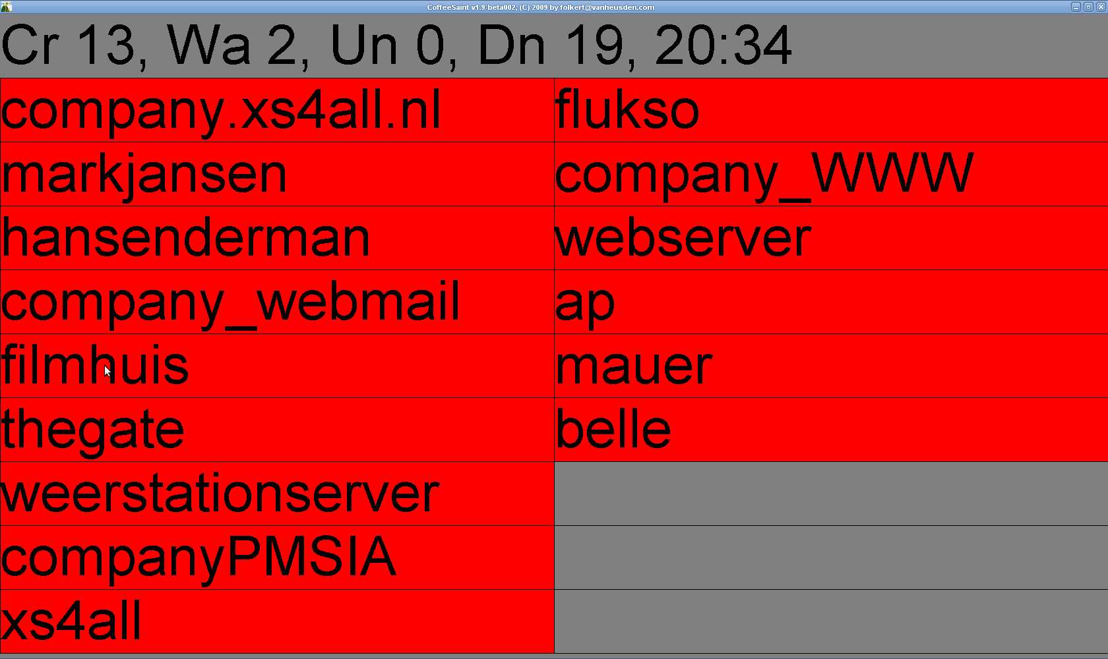

logo
Display a logo on the screen, in the header-line.

logo-position
Where to display the logo. Can be either “left” or “right”.

Logo example (the Nagios-logo right):

anti-alias
When drawing the screen (the problems, images, etc.) use anti-aliasing. This improves how for example the fonts are rendered but it slows down the program.

max-quality-graphics
This setting improves the rendering settings. Slows down the program.

header
What to display in the header (top-most row). This string can contain escapes (%... and @...@, see chapter “scapes”).

footer
What to display in the footer (bottom row). If there's any problem, this row is replaced by the error message. Can also contain escapes. If this command is omitted, no footer line is displayed: makes more room for listing problems.

no-header
Don't display a header-line. Gives one more row for displaying problems.

sort-order
Selects the field to sort on. The names of the fields can be found in the nagios status.dat file which are explained at. If a field contains a numeric value, you can put “numeric” before the field-name. It'll then do a numeric-sort. If you put “reverse” in front of it, it'll do a reverse sort (biggest values at the top / strings starting with a 'z' at the top). See chapter “Nagios status.dat fields”.

prefer
Comma seperated list of texts that are displayed at the top. This list can be a list of regular expressions. See http://download.oracle.com/javase/6/docs/api/java/util/regex/Pattern.html for a description of what Java expects.

also-acknowledged
Display acknowledged (in Nagios itself) problems as well . Requires “true” or “false”.

always-notify
Also display problems for which notifications are disabled .

also-scheduled-downtime
Also display problems for which downtime has been scheduled .

also-soft-state
Also display problems that are not yet in hard state

also-disabled-active-checks
Also display problems for which active checks have been disabled .

show-flapping
Do not show hosts that are flapping .

show-flapping-icon
Show an icon in front of problems indicating wether they're flapping or not .

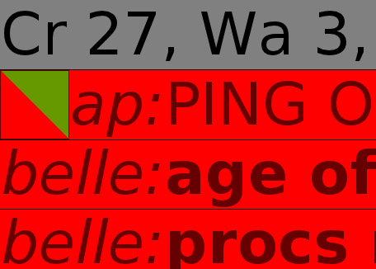

filter-unknown
Do not show hosts/services in unknown or pending state .

filter-down
Do not show hosts in down state .

show-services-for-host-with-problems
Default behaviour is not to display service-states for a host that is down as most of the time those services will be down as well.

counter
Display a counter which shows the number of seconds before the screen will refresh (see “interval”).

counter-position
Where to put the counter. Can be one of the following:
- upper-left
- upper-right
- lower-left
- lower-right
- center
- nowhere

problem-row-gradient
Don't let problems have a solid background color but display a gradient instead.

bgcolor
Select background color (get a list of available colors with “--list-bgcolors”).

bgcolor-fade-to
Select the color to fade the background to.

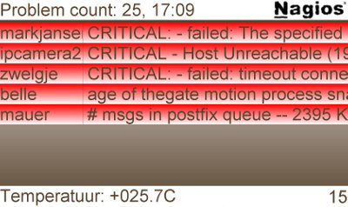

sound
Selects the audio-file to play when a new problem was detected. This must be in a format that is supported by Java. See http://java.sun.com/products/java-media/sound/techReference/javasoundfaq.html#formats for a list of formats.

exec
Selects a script/program to execute when a new probem is shown.

verbose
Let CoffeeSaint be a little more verbose on what it is doing. This for example shows what Nagios source it is retrieving. This information is shown in the header-row.

text-color
Color of header and footer texts.

warning-textcolor
Color of the warning problem texts.

critical-textcolor
Color of critical problem texts.

color-bg-state
When set to true, then the background color depends on the state. Critical errors will give for example a red background.

warning-bg-color
Background color to use when the biggest problem is a warning. Default is yellow.

critical-bg-color
Background color to use when the biggest problem is a critical. Default is red.

nagios-unknown-bg-color
Background color to use when the biggest issue has a uknown state.

font
Default font to use (e.g. header and footer texts).

critical-font
Font to use for critical problems.

warning-font
Font to use for warning-level problems.

splitter
This parameter can have one or more x-positions. They set the tab-stops. See the “\T” escape in the escapes section.

draw-problems-service-split-line
When set to “true” show a vertical line on each tab-stop.
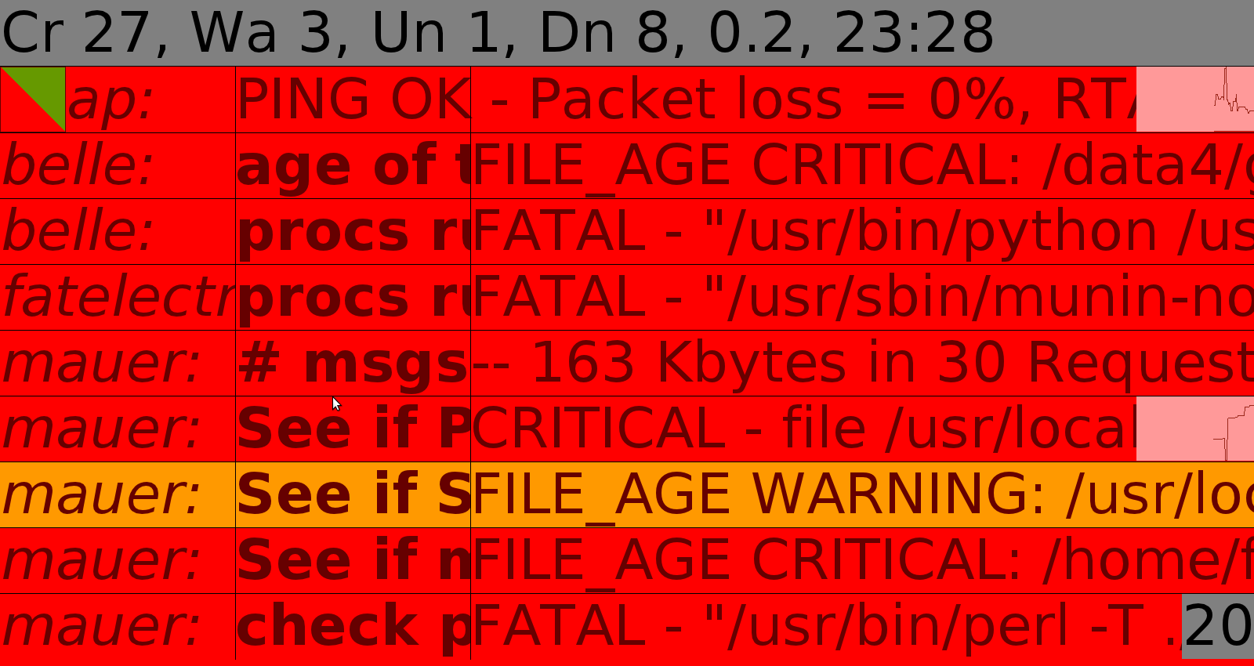

no-problems-text
Message to display when there are no problems. Used by the %STATE escape.

state-problems-text
Message to display when there are problems. Used by the %STATE escape.

row-border
Draws a border around each shown problem.

row-border-color
Color of the border around each problem. Default is black.

host-issue
When there's a problem with a host, what to show. Normally consists of a couple of escapes selecting what to show.

service-issue
When there's a problem with a service, what to show. Normally consists of a couple of escapes selecting what to show.

reduce-textwidth
When the text of a problem doesn't fit on the screen or in a column, shrink the font so that it fits.

scroll-if-not-fitting
If the problem text (with all escapes expanded) does not fit on the screen, this setting will make it scroll (from right to left).

scroll-pixels-per-sec
Number of pixels to scroll per second (default: 100) . This sets the scrolling speed.

scrolling-header
Sets if the header should scroll if it doesn't fit.

hosts-filter-exclude
Comma-seperated list of hosts not to display .

hosts-filter-include
Comma-seperated list of hosts to display. Use in combination with hosts-filter-exclude: will be invoked after the exclude.

services-filter-exclude
Comma-seperated list of services not to display .

services-filter-include
Comma-seperated list of services to display. Use in combination with services-filter-exclude: will be invoked after the exclude.

sparkline-width
Adds sparklines to the listed problems. With this setting you enable them AND you define the width in pixels. The sparklines are graphs of the performance data which is measured by Nagios.

sparkline-mode
Defines how the measured data will be scaled.
- avg-sd: scale to [average – standard deviation] to [average + standard deviation]
- min-max: scale to the whole y-axis bandwidth

graph-color
Selects the color with which the graphs are drawn.

max-check-age
With this CoffeeSaint will check if (all) Nagios server(s) are up. That is: if its(their) checks were not performed longer than what you select with this parameter. It expects the number of seconds. Two notes: the value must be equal or larger than the refresh-interval (the “interval” parameter), also: make this value somewhat larger than if “interval_length” (in nagios.cfg, default is 60 seconds) multiplied by the smallest “normal_check_interval” in the services definitions.

performance-data-filename
In what file CoffeeSaint should store the performance data as measured by Nagios. Please note that if CoffeeSaint is not running, then there will be gaps.

Escapes
CoffeeSaint has two kinds of escapes: escapes that show details on problems, retrieved from the Nagios status.dat (textual escapes), and escapes that set font style parameters.

Font style escapes
Escapes can be combined (e.g. both italic and bold). One “stops” a setting by repeating it's escape: \B...\B.
- \B show the following text in bold
- \I show the following text in italic
- \U show the following text with underline
- \S show the following text with strike-through
- \T let the following text start at the next tab-stop (see “splitter”) - this escape does not require a terminating \T (!)

Textual escapes

%CRITICAL
Total number of critical problems.

%WARNING
Total number of warning problems.

%OK
Total number of services that have the OK state.

%UP
Total number of hosts that are up.

%DOWN
Total number of hosts that are down.

%UNREACHABLE
Total number of hosts that are unreachable.

%PENDING
Total of hosts for which the status is not yet known.

%TOTALISSUES
Sum of critital, warning, down and unreachable.

%STATE
Contents of the “no-problems-text” or “state-problems-text” parameters, depending on the worst state.

%H:%M
Current time.

%HOSTNAME / %SERVICENAME
Use for “host-issue” and/or “service-issue”.

%SERVERNAME
Name of the Nagios server on which the current problem is happening.

%HOSTSTATE / %SERVICESTATE
Current state, e.g. “Ok”, “Critital”.

%HOSTSINCE / %SERVICESINCE
Textual timestamp of when the problem started.

%HOSTSINCETS / %SERVICESINCETS
Number of seconds since the start of a problem. These escapes are especially usefull for conditional escapes.

%HOSTFLAPPING / %SERVICEFLAPPING
Tells you if the state is flapping.

%PREDICT / %HISTORICAL
To be described.

%HOSTDURATION / %SERVICEDURATION
How long a host/service has been in the current state.

%OUTPUT
Output of the Nagios plugin that indicated a problem.

@FIELDDATEHOST^field@
Take 'field' from the host-field (from the Nagios status.dat) and convert it into a date-string. E.g. when you have a field in status.dat that contains a timestamp (e.g. last_state_change=1310935509), this will then convert that to something readable (year/month/day etc.).

@FIELDDATESERVICE^field@
Take 'field' from the service-fields and convert it into a date-string .

@FIELDBOOLEANHOST^field@
Take 'field' from the host-fields and interpret as yes/no. If there's a field containing a boolean (e.g. has_been_checked=1), this escape will convert that to 'yes' or 'no'.

@FIELDBOOLEANSERVICE^field@
Take 'field' from the service-fields and interpret as yes/no .

@FIELDHOST^field@
Take 'field' from the host-fields and display its contents. E.g. it'll display “0.030” when you pick the field check_execution_time.

@FIELDSERVICE^field@
Take 'field' from the service-fields and display its contents.

@FIELD^x@
x can be 'field|service|host' or 'field|host' or 'field'. Here you need to replace 'host' with the host from which you want to see the status.dat field “field”. Same thing for service. So @FIELD^check_type|ping^myhost@ will show the contents of the field “check_type” from the service “ping” on host “myhost”.

@EXEC^script@
This escape invokes “script” and shows the first line of it's output.
The script gets as output:
- hostname
- servicename (or an empty field in case of a host failure)
- current state
- plugin output
UNIX example:
@exec^/usr/local/bin/my_script.sh@
Windows example:
@exec^c:\programs\myprogam.exe@

%PERCENT
Is replaced by a '%'.

%AT
Will be replaced by a '@'.

%CHECKLATENCY
Shows the latency of the check that indicated the problem.

%NACKED
The number of acknowledged problems.

%NFLAPPING
The number of problems for which the state is flapping.

Nagios status.dat fields
These fields can be found in the Nagios status.dat file. They can be used for sorting and filtering.

Sorting

Time
last_check
last_hard_state_change
last_state_change
last_time_critical
last_time_down
last_time_ok
last_time_unknown
last_time_unreachable
last_time_up
last_time_warning
last_update
next_check
next_notification

Measurements
check_execution_time
check_latency
percent_state_change

IDs
current_event_id
current_notification_id
current_problem_id
last_event_id
last_problem_id

Miscellaneous fields
acknowledgement_type
active_checks_enabled
check_command
check_interval
check_options
check_period
check_type
current_attempt
current_notification_number
current_state
event_handler
event_handler_enabled
failure_prediction_enabled
flap_detection_enabled
has_been_checked
host_name
is_flapping
last_hard_state
last_notification
long_plugin_output
max_attempts
modified_attributes
no_more_notifications
notification_period
notifications_enabled
obsess_over_host
obsess_over_service
passive_checks_enabled
performance_data
plugin_output
problem_has_been_acknowledged
process_performance_data
retry_interval
scheduled_downtime_depth
service_description
should_be_scheduled
state_type

Acknowledgements
- Logo/ graphical design web-interface: Bastiaan Schuilings (www.properlydecent.com)

